1. The database was hosted at localhost using phpMyAdmin and XAMPP.

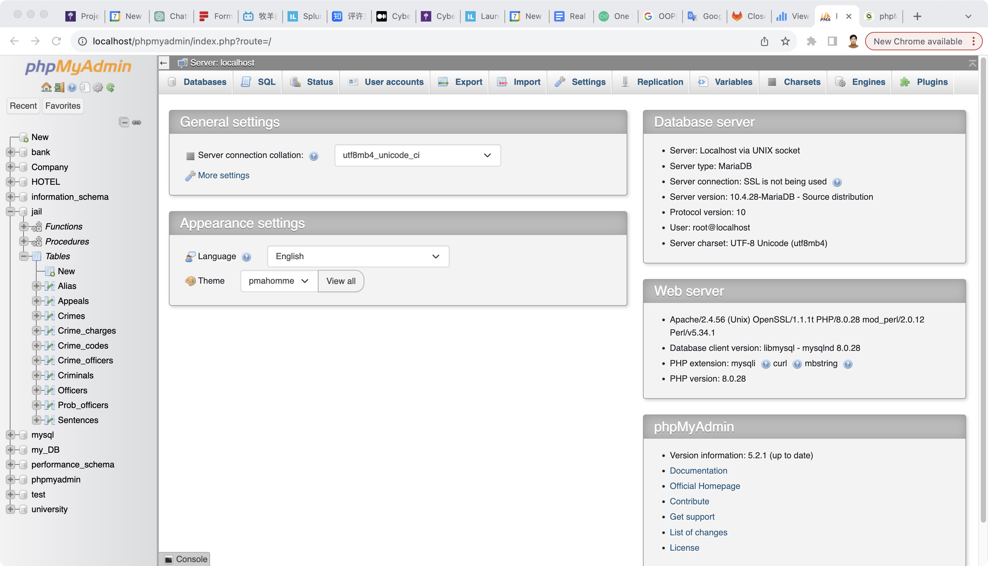

1. Table schemas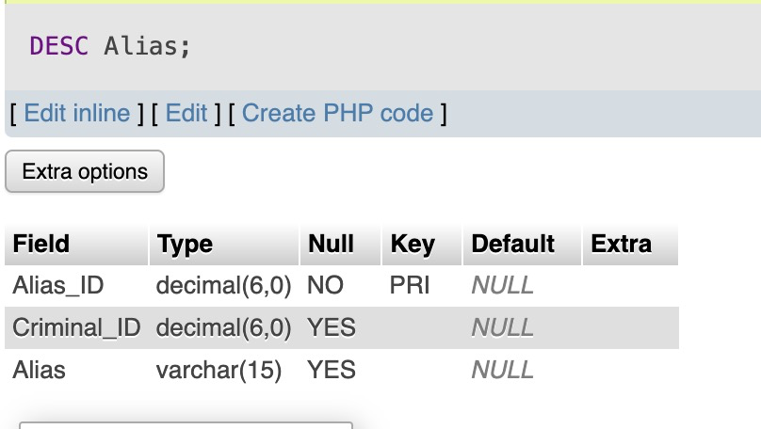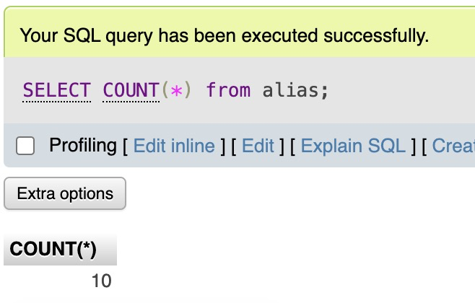

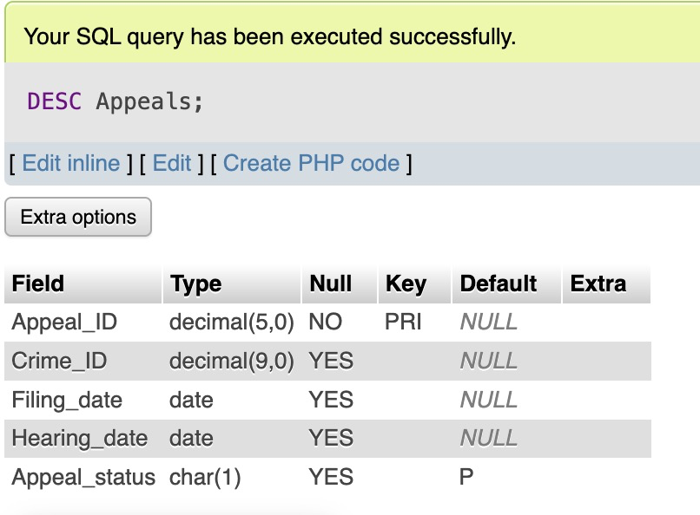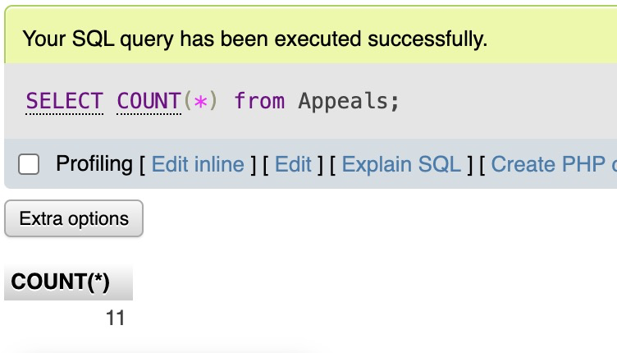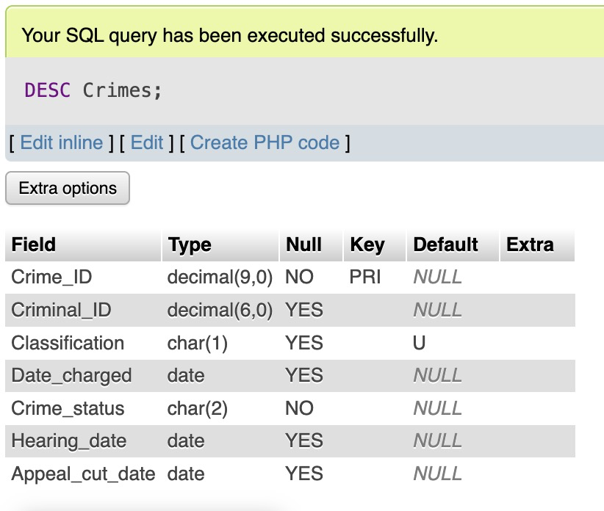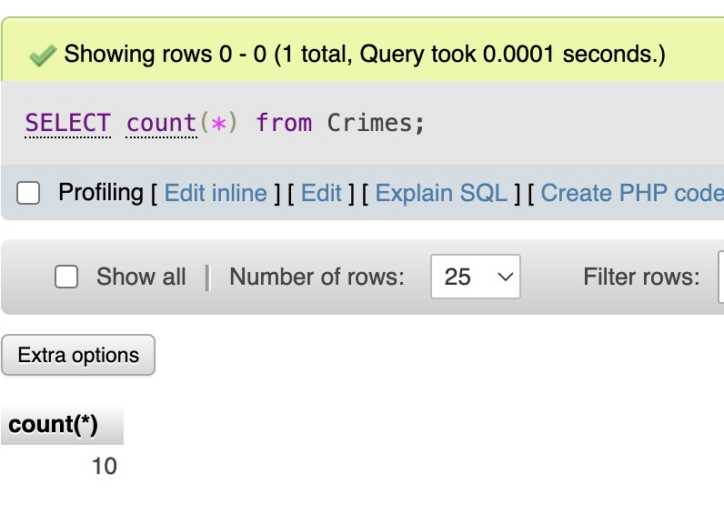

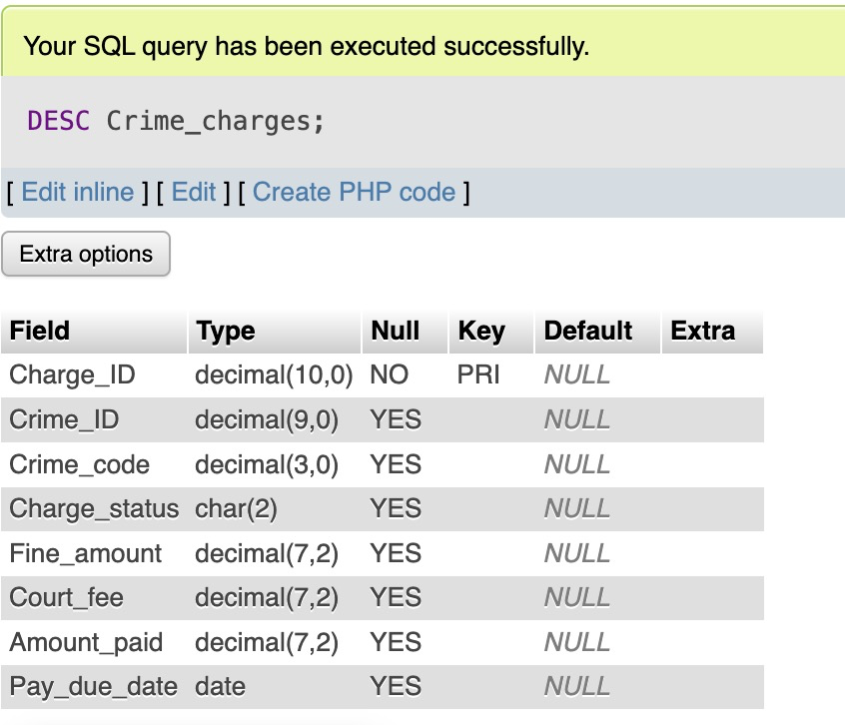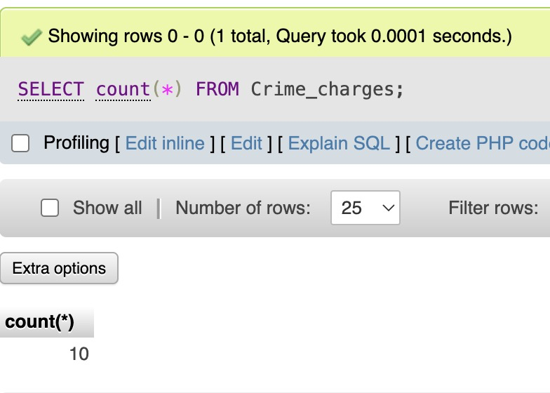

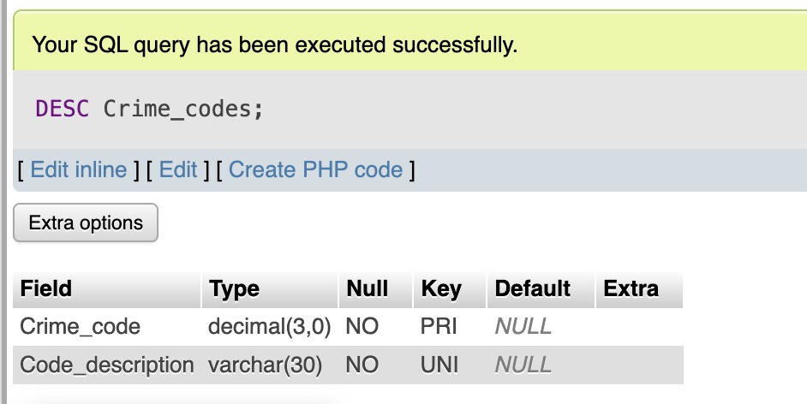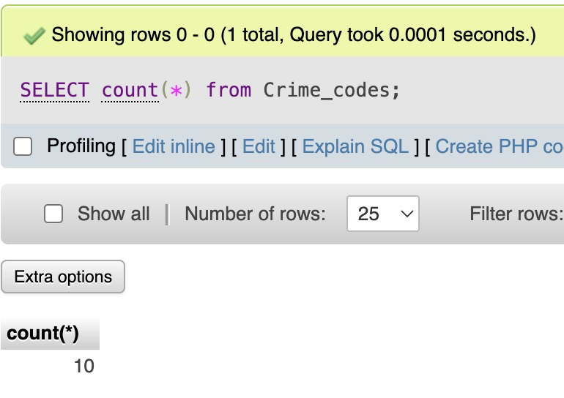

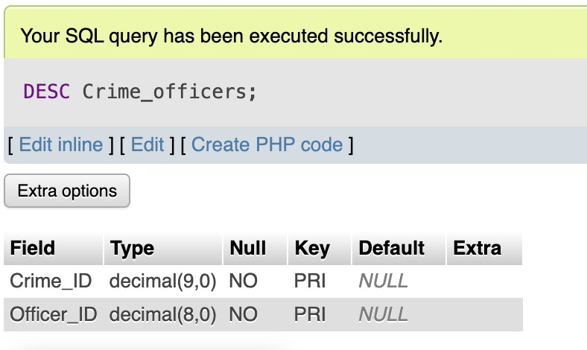

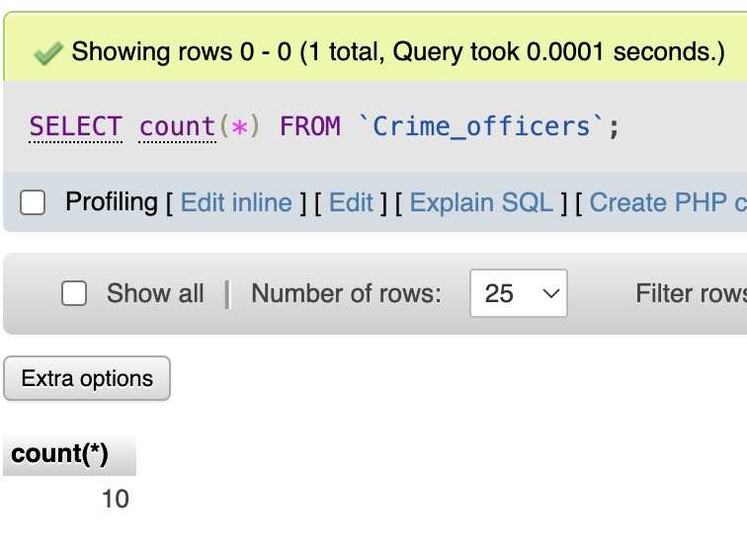

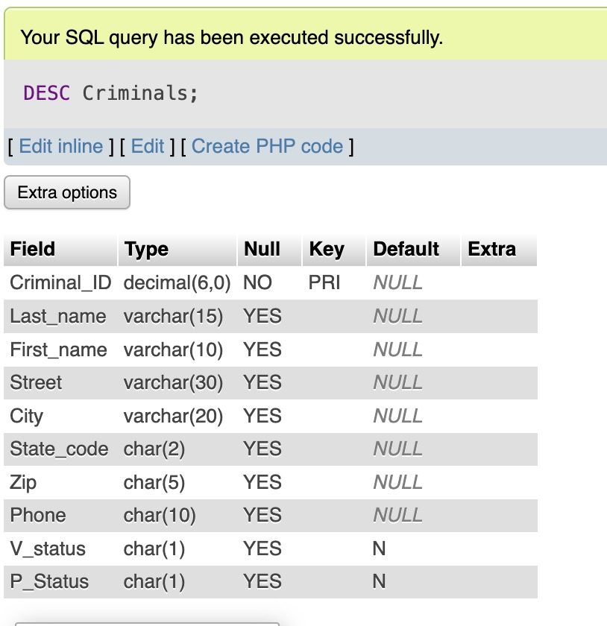

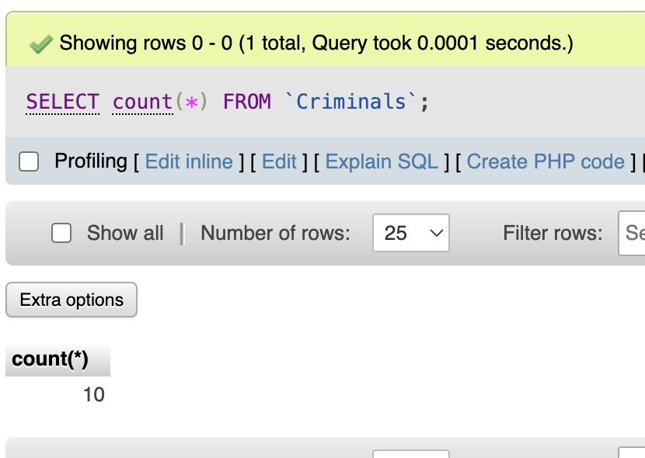

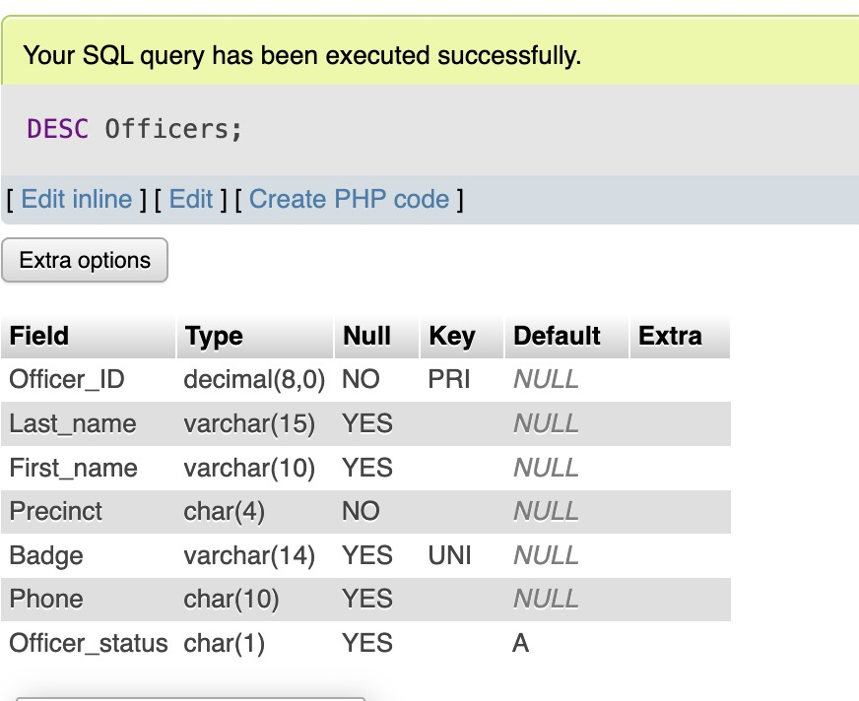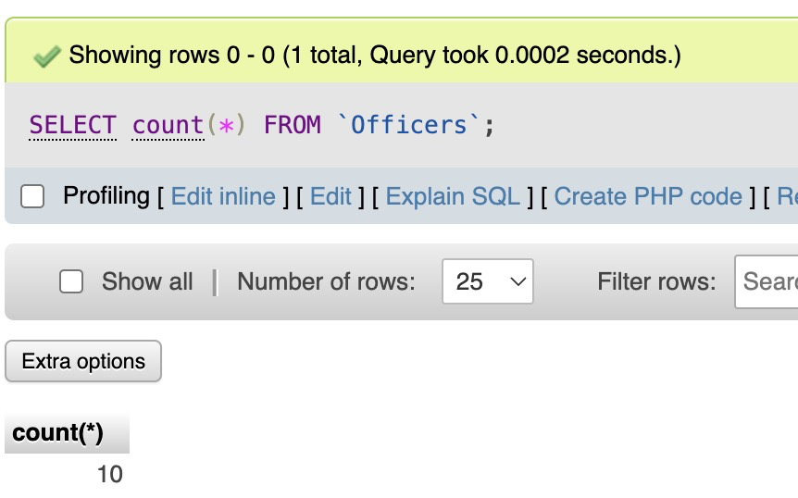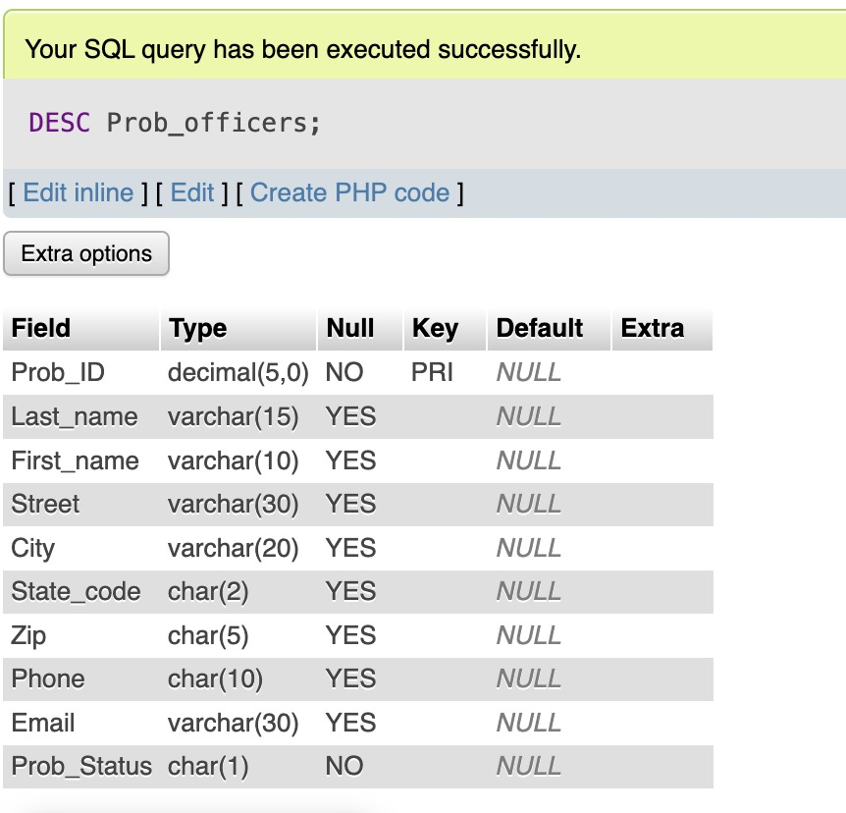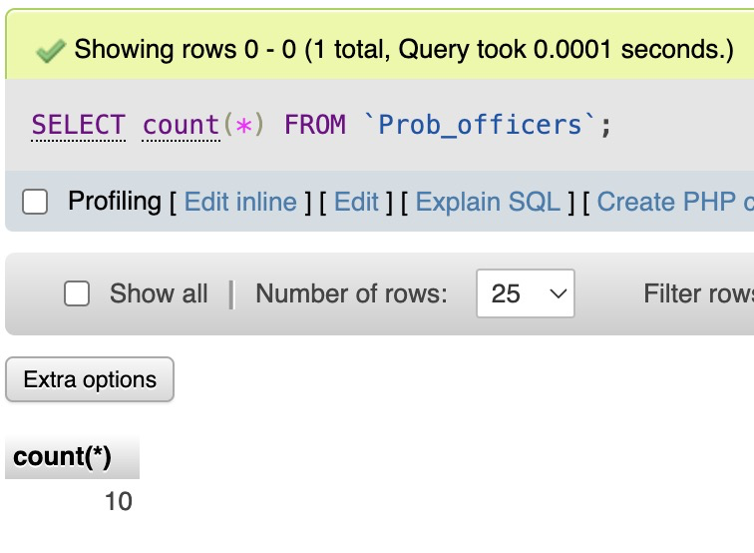

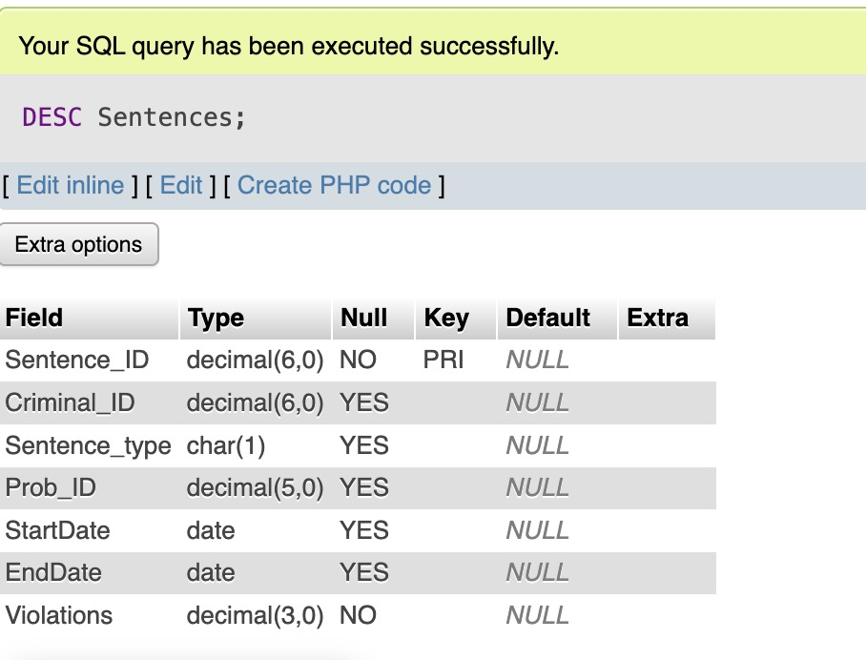

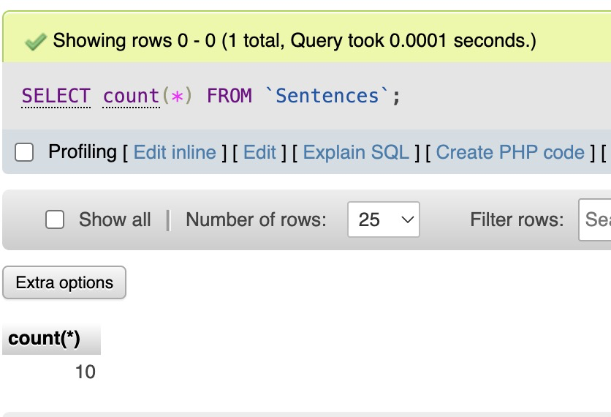

1. Data evidence

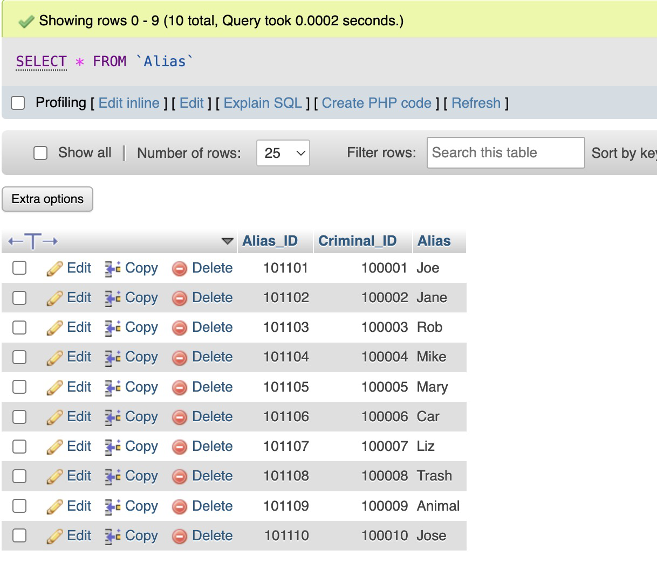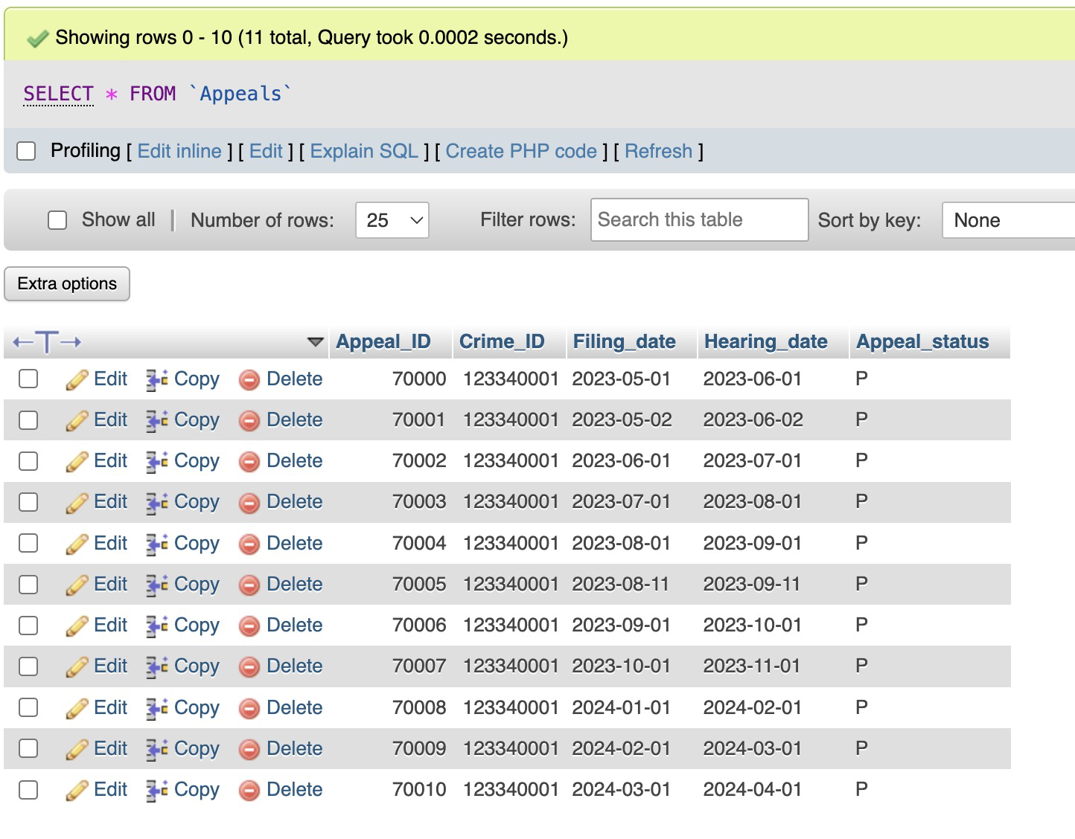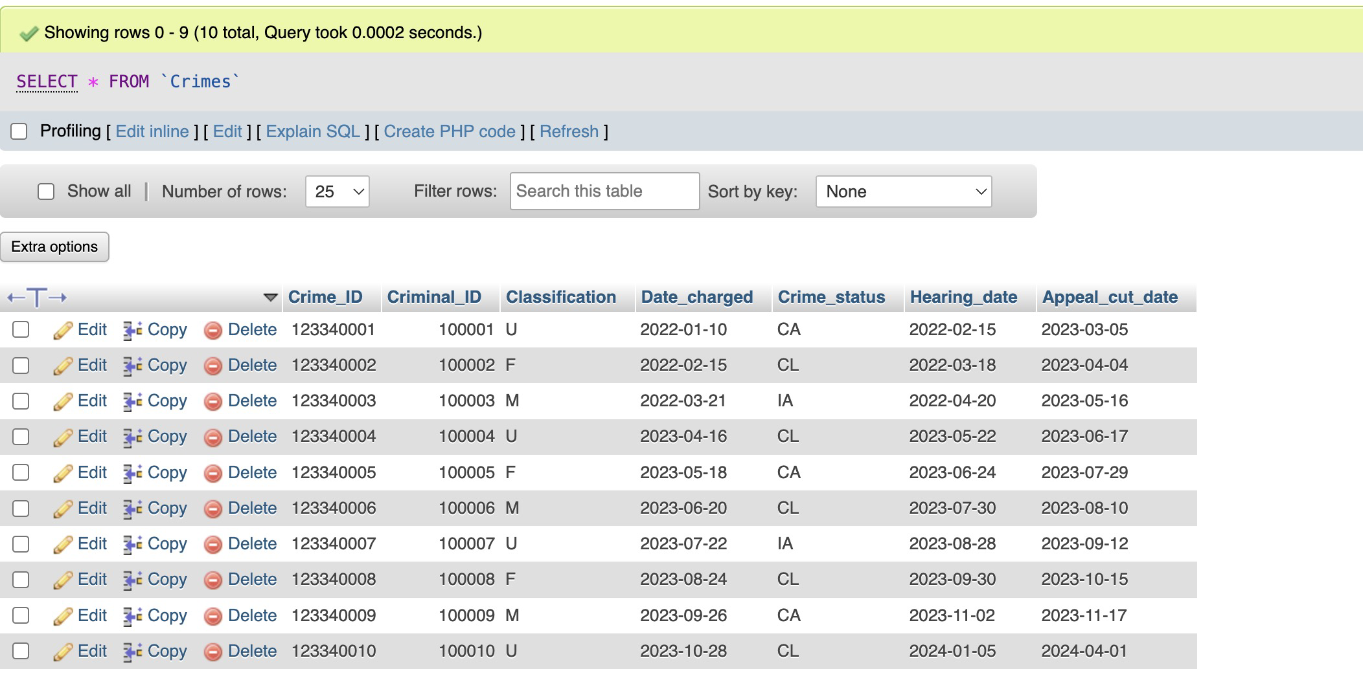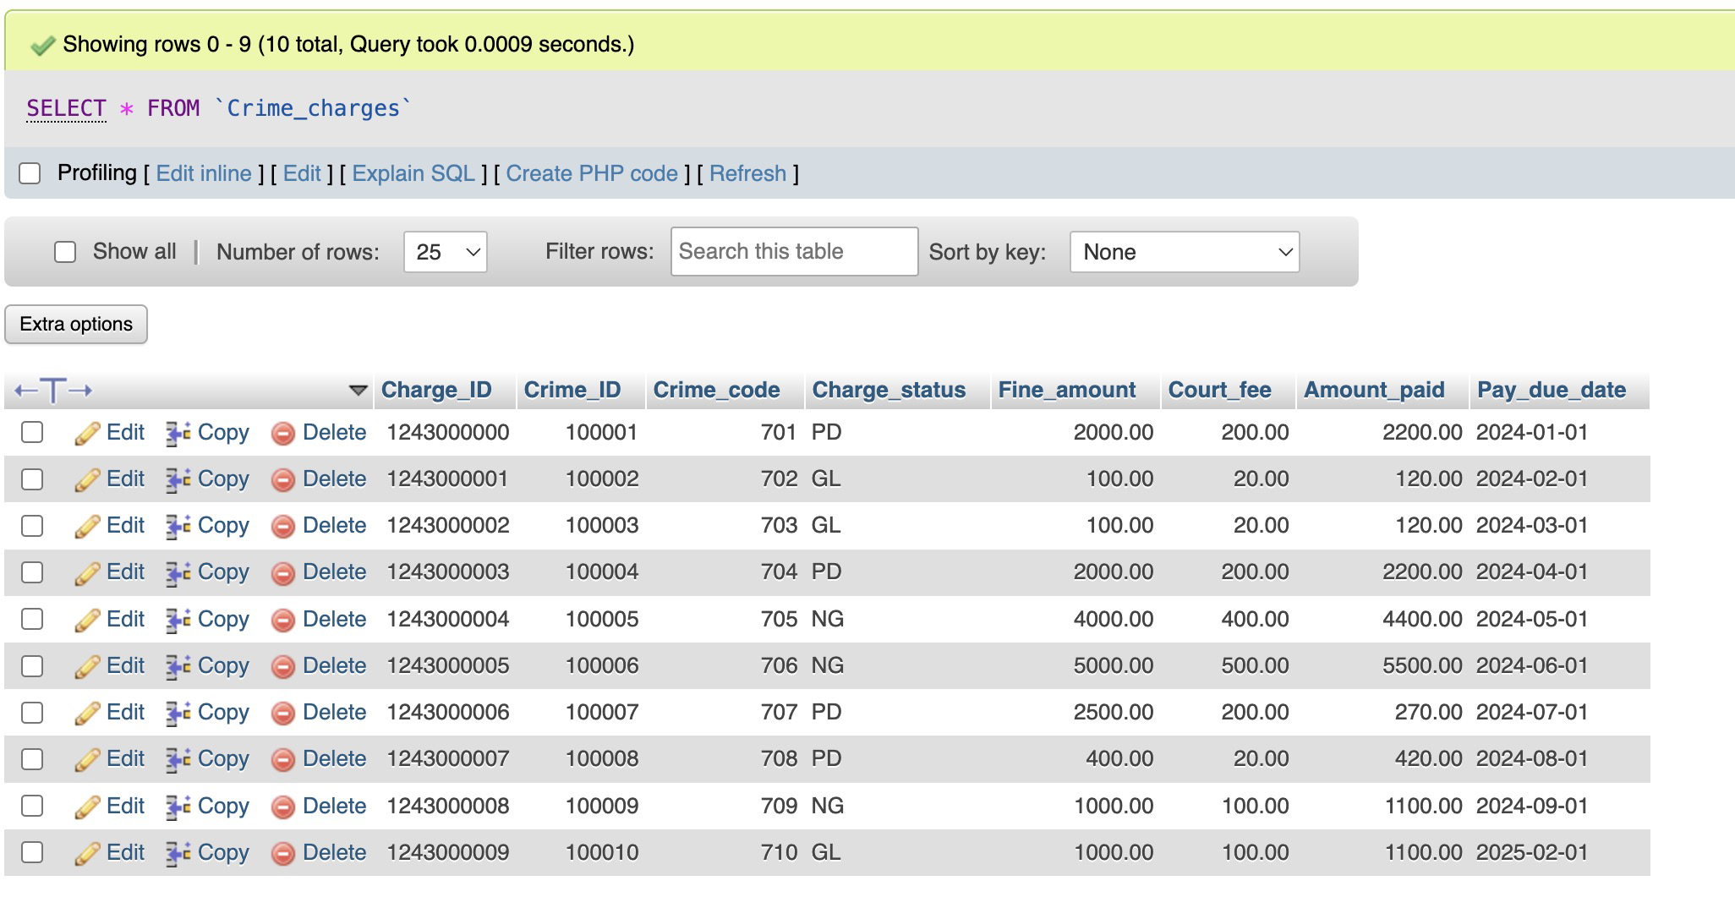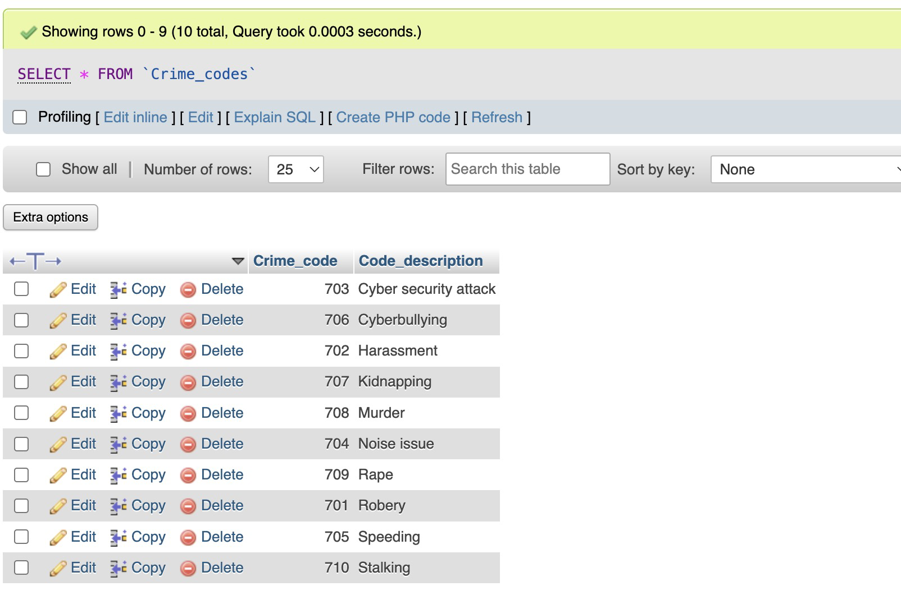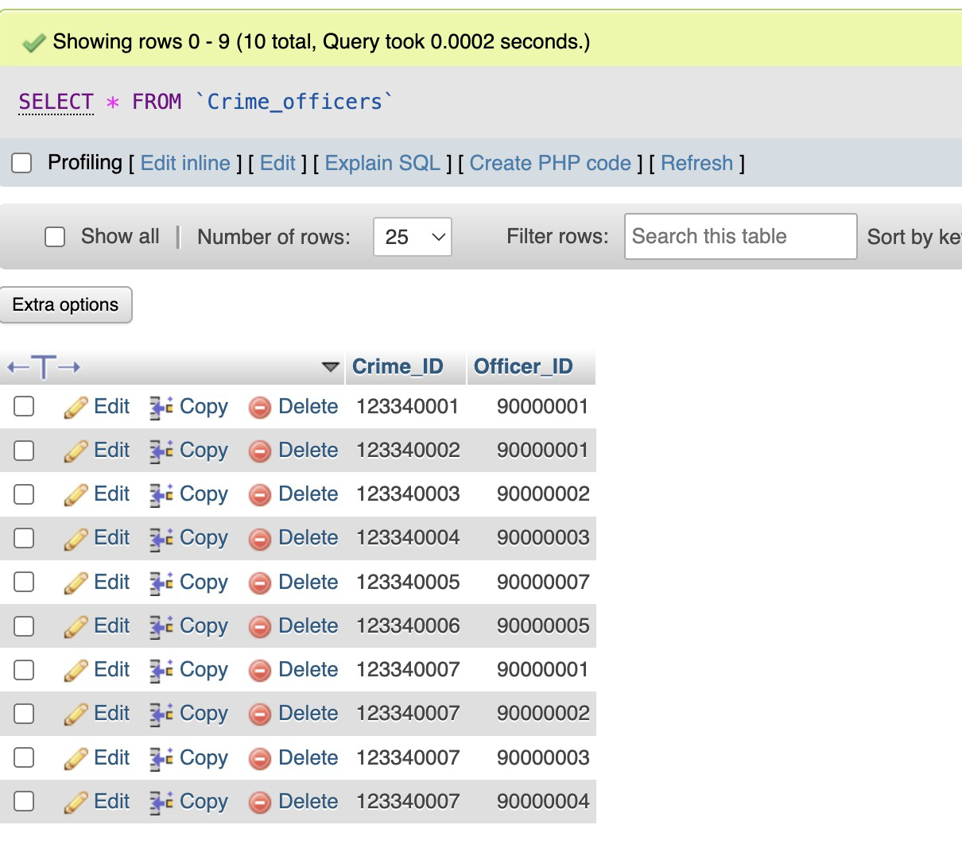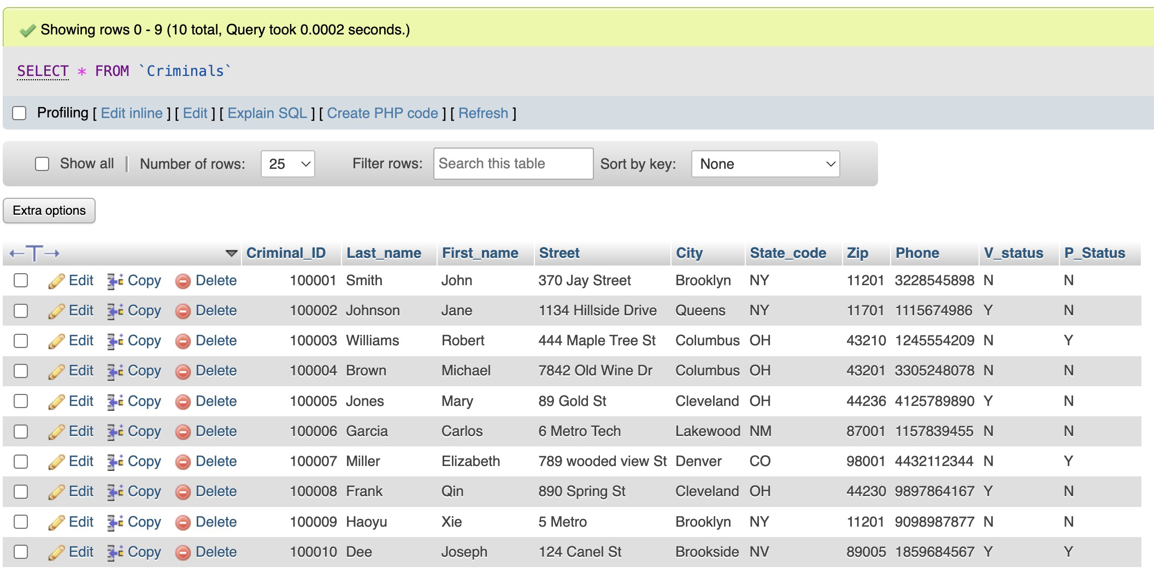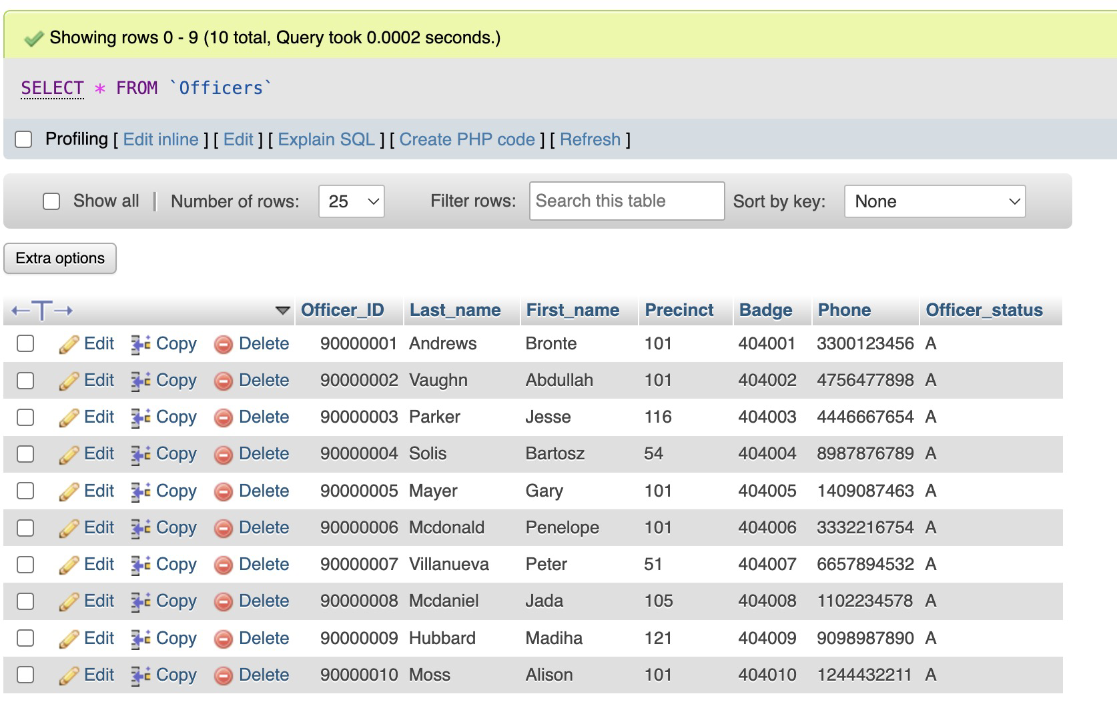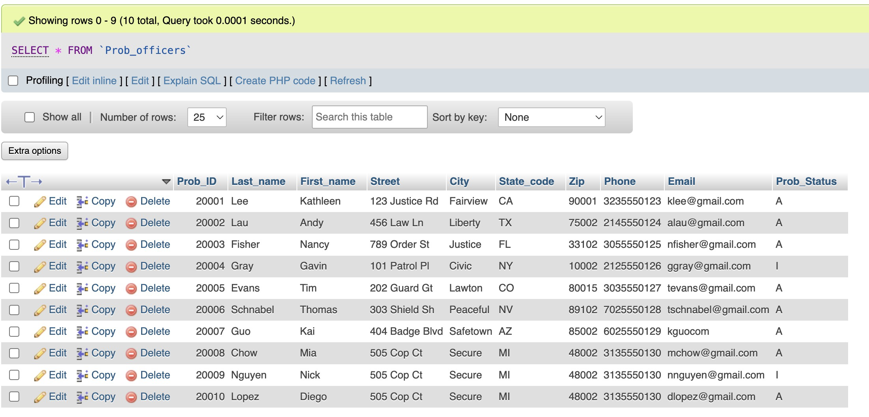

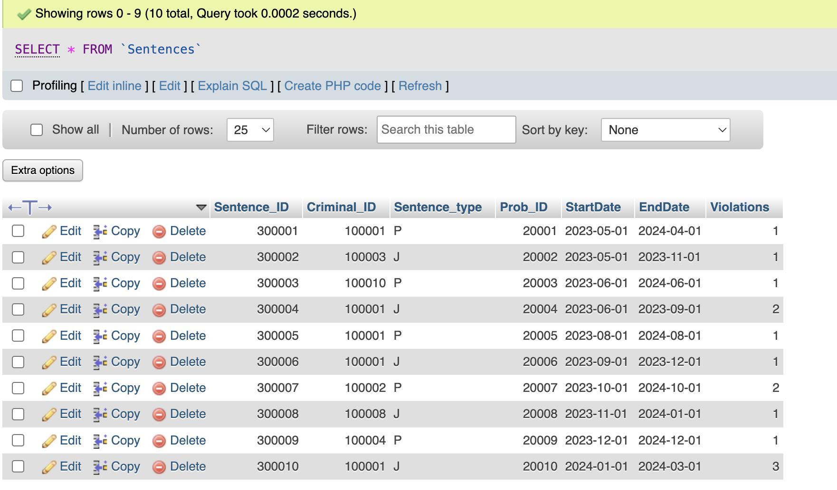

1. All SQL commands

create table Criminals(

Criminal_ID DECIMAL(6, 0),

Last_name VARCHAR(15),

First_name VARCHAR(10),

Street VARCHAR(30),

City VARCHAR(20),

State_code CHAR(2),

Zip CHAR(5),

Phone CHAR(10),

V_status CHAR(1) DEFAULT 'N',

P_Status CHAR(1) DEFAULT 'N',

PRIMARY KEY (Criminal_ID),

CHECK (V_status = 'Y' OR V_status = 'N'),

CHECK (P_status = 'Y' OR P_status = 'N')

);

create table Alias(

Alias_ID DECIMAL(6, 0),

Criminal_ID DECIMAL(6, 0) REFERENCES Criminals(Criminal_ID),

Alias VARCHAR(15),

PRIMARY KEY (Alias_ID)

);

create table Crimes(

Crime_ID DECIMAL(9, 0),

Criminal_ID DECIMAL(6, 0) REFERENCES Criminals(Criminal_ID),

Classification CHAR(1) DEFAULT 'U',

Date_charged DATE,

Crime_status CHAR(2) NOT NULL,

Hearing_date DATE,

Appeal_cut_date DATE,

PRIMARY KEY (Crime_ID),

CHECK (hearing_date > date_charged),

CHECK (Classification IN ('F', 'M', 'O', 'U')),

CHECK (Crime_status IN ('CL', 'CA', 'IA'))

);

create table Prob_officers(

Prob_ID DECIMAL(5, 0),

Last_name VARCHAR(15),

First_name VARCHAR(10),

Street VARCHAR(30),

City VARCHAR(20),

State_code CHAR(2),

Zip CHAR(5),

Phone CHAR(10),

Email VARCHAR(30),

Prob_Status CHAR(1) NOT NULL,

PRIMARY KEY (Prob_ID),

CHECK (Prob_status IN ('A', 'I'))

);

create table Sentences(

Sentence_ID DECIMAL(6, 0),

Criminal_ID DECIMAL(6, 0) REFERENCES Criminals(Criminal_ID),

Sentence_type CHAR(1),

Prob_ID DECIMAL(5, 0) REFERENCES Prob_officers(Prob_ID),

StartDate DATE,

EndDate DATE,

Violations DECIMAL(3, 0) NOT NULL,

PRIMARY KEY (Sentence_ID),

CHECK (EndDate > StartDate),

CHECK (Sentence_type IN ('J', 'H', 'P'))

);

create table Officers(

Officer_ID DECIMAL(8, 0),

Last_name VARCHAR(15),

First_name VARCHAR(10),

Precinct CHAR(4) NOT NULL,

Badge VARCHAR(14),

Phone CHAR(10),

Officer_status CHAR(1) DEFAULT 'A',

UNIQUE (Badge),

PRIMARY KEY (Officer_ID),

CHECK (Officer_status IN ('A', 'I'))

);

create table Crime_officers(

Crime_ID DECIMAL(9, 0) REFERENCES Crimes(Crime_ID),

Officer_ID DECIMAL(8, 0) REFERENCES Officers(Officer_ID),

PRIMARY KEY (Crime_ID, Officer_ID)

);

create table Appeals(

Appeal_ID DECIMAL(5, 0),

Crime_ID DECIMAL(9, 0) REFERENCES Crimes(Crime_ID),

Filing_date DATE,

Hearing_date DATE,

Appeal_status CHAR(1) DEFAULT 'P',

PRIMARY KEY (Appeal_ID),

CHECK (Appeal_status IN ('P', 'A', 'D'))

);

create table Crime_codes(

Crime_code DECIMAL(3, 0) NOT NULL,

Code_description VARCHAR(30) NOT NULL,

UNIQUE(Code_description),

PRIMARY KEY (Crime_code)

);

create table Crime_charges(

Charge_ID DECIMAL(10, 0),

Crime_ID DECIMAL(9, 0) REFERENCES Crimes(Crime_ID),

Crime_code DECIMAL(3, 0) REFERENCES Crime_code(Crime_code),

Charge_status CHAR(2),

Fine_amount DECIMAL(7, 2),

Court_fee DECIMAL(7, 2),

Amount_paid DECIMAL(7, 2),

Pay_due_date DATE,

PRIMARY KEY (Charge_ID),

CHECK (Charge_status IN ('PD', 'GL', 'NG'))

);

INSERT INTO Criminals (Criminal_ID, Last_name, First_name, Street, City, State_code, Zip, Phone, V_status, P_Status) VALUES

(100001, 'Smith', 'John', '370 Jay Street', 'Brooklyn', 'NY', '11201', '3228545898', 'N', 'N'),

(100002, 'Johnson', 'Jane', '1134 Hillside Drive', 'Queens', 'NY', '11701', '1115674986', 'Y', 'N'),

(100003, 'Williams', 'Robert', '444 Maple Tree St', 'Columbus', 'OH', '43210', '1245554209', 'N', 'Y'),

(100004, 'Brown', 'Michael', '7842 Old Wine Dr', 'Columbus', 'OH', '43201', '3305248078', 'N', 'N'),

(100005, 'Jones', 'Mary', '89 Gold St', 'Cleveland', 'OH', '44236', '4125789890', 'Y', 'N'),

(100006, 'Garcia', 'Carlos', '6 Metro Tech', 'Lakewood', 'NM', '87001', '1157839455', 'N', 'N'),

(100007, 'Miller', 'Elizabeth', '789 wooded view St', 'Denver', 'CO', '98001', '4432112344', 'N', 'Y'),

(100008, 'Frank', 'Qin', '890 Spring St', 'Cleveland', 'OH', '44230', '9897864167', 'Y', 'N'),

(100009, 'Haoyu', 'Xie', '5 Metro', 'Brooklyn', 'NY', '11201', '9098987877', 'N', 'N'),

(100010, 'Dee', 'Joseph', '124 Canel St', 'Brookside', 'NV', '89005', '1859684567', 'Y', 'Y');

INSERT INTO Alias (Alias_ID, Criminal_ID, Alias) VALUES

(101101, 100001, 'Joe'),

(101102, 100002, 'Jane'),

(101103, 100003, 'Rob'),

(101104, 100004, 'Mike'),

(101105, 100005, 'Mary'),

(101106, 100006, 'Car'),

(101107, 100007, 'Liz'),

(101108, 100008, 'Trash'),

(101109, 100009, 'Animal'),

(101110, 100010, 'Jose');

INSERT INTO CRIMES (Crime_ID, Criminal_ID, Classification, Date_charged, Crime_status, Hearing_date, Appeal_cut_date) VALUES

(123340001, 100001, 'U', '2022-01-10', 'CA', '2022-02-15', '2023-03-05'),

(123340002, 100002, 'F', '2022-02-15', 'CL', '2022-03-18', '2023-04-04'),

(123340003, 100003, 'M', '2022-03-21', 'IA', '2022-04-20', '2023-05-16'),

(123340004, 100004, 'U', '2023-04-16', 'CL', '2023-05-22', '2023-06-17'),

(123340005, 100005, 'F', '2023-05-18', 'CA', '2023-06-24', '2023-07-29'),

(123340006, 100006, 'M', '2023-06-20', 'CL', '2023-07-30', '2023-08-10'),

(123340007, 100007, 'U', '2023-07-22', 'IA', '2023-08-28', '2023-09-12'),

(123340008, 100008, 'F', '2023-08-24', 'CL', '2023-09-30', '2023-10-15'),

(123340009, 100009, 'M', '2023-09-26', 'CA', '2023-11-02', '2023-11-17'),

(123340010, 100010, 'U', '2023-10-28', 'CL', '2024-01-05', '2024-04-01');

INSERT INTO Prob_officers (Prob_ID, Last_name, First_name, Street, City, State_code, Zip, Phone, Email, Prob_Status) VALUES

(20001, 'Lee', 'Kathleen', '123 Justice Rd', 'Fairview', 'CA', '90001', '3235550123', 'klee@gmail.com', 'A'),

(20002, 'Lau', 'Andy', '456 Law Ln', 'Liberty', 'TX', '75002', '2145550124', 'alau@gmail.com', 'A'),

(20003, 'Fisher', 'Nancy', '789 Order St', 'Justice', 'FL', '33102', '3055550125', 'nfisher@gmail.com', 'A'),

(20004, 'Gray', 'Gavin', '101 Patrol Pl', 'Civic', 'NY', '10002', '2125550126', 'ggray@gmail.com', 'I'),

(20005, 'Evans', 'Tim', '202 Guard Gt', 'Lawton', 'CO', '80015', '3035550127', 'tevans@gmail.com', 'A'),

(20006, 'Schnabel', 'Thomas', '303 Shield Sh', 'Peaceful', 'NV', '89102', '7025550128', 'tschnabel@gmail.com', 'A'),

(20007, 'Guo', 'Kai', '404 Badge Blvd', 'Safetown', 'AZ', '85002', '6025550129', 'kguocom', 'A'),

(20008, 'Chow', 'Mia', '505 Cop Ct', 'Secure', 'MI', '48002', '3135550130', 'mchow@gmail.com', 'A'),

(20009, 'Nguyen', 'Nick', '505 Cop Ct', 'Secure', 'MI', '48002', '3135550130', 'nnguyen@gmail.com', 'I'),

(20010, 'Lopez', 'Diego', '505 Cop Ct', 'Secure', 'MI', '48002', '3135550130', 'dlopez@gmail.com', 'A');

INSERT INTO Sentences (Sentence_ID, Criminal_ID, Sentence_type, Prob_ID, StartDate, EndDate, Violations) VALUES

(300001, 100001, 'P', 20001, '2023-05-01', '2024-04-01', 1),

(300002, 100003, 'J', 20002, '2023-05-01', '2023-11-01', 1),

(300003, 100010, 'P', 20003, '2023-06-01', '2024-06-01', 1),

(300004, 100001, 'J', 20004, '2023-06-01', '2023-09-01', 2),

(300005, 100001, 'P', 20005, '2023-08-01', '2024-08-01', 1),

(300006, 100001, 'J', 20006, '2023-09-01', '2023-12-01', 1),

(300007, 100002, 'P', 20007, '2023-10-01', '2024-10-01', 2),

(300008, 100008, 'J', 20008, '2023-11-01', '2024-01-01', 1),

(300009, 100004, 'P', 20009, '2023-12-01', '2024-12-01', 1),

(300010, 100001, 'J', 20010, '2024-01-01', '2024-03-01', 3);

INSERT INTo Officers (Officer_ID, Last_name, First_name, Precinct, Badge, Phone, Officer_status) VALUES

(90000001, 'Andrews', 'Bronte', '101', '404001', '3300123456', 'A'),

(90000002, 'Vaughn', 'Abdullah', '101', '404002', '4756477898', 'A'),

(90000003, 'Parker', 'Jesse', '116', '404003', '4446667654', 'A'),

(90000004, 'Solis', 'Bartosz', '54', '404004', '8987876789', 'A'),

(90000005, 'Mayer', 'Gary', '101', '404005', '1409087463', 'A'),

(90000006, 'Mcdonald', 'Penelope', '101', '404006', '3332216754', 'A'),

(90000007, 'Villanueva', 'Peter', '51', '404007', '6657894532', 'A'),

(90000008, 'Mcdaniel', 'Jada', '105', '404008', '1102234578', 'A'),

(90000009, 'Hubbard', 'Madiha', '121', '404009', '9098987890', 'A'),

(90000010, 'Moss', 'Alison', '101', '404010', '1244432211', 'A');

INSERT INTO Crime_officers(Crime_ID, Officer_ID) VALUES

(123340001, 90000001),

(123340002, 90000001),

(123340003, 90000002),

(123340004, 90000003),

(123340005, 90000007),

(123340006, 90000005),

(123340007, 90000001),

(123340007, 90000002),

(123340007, 90000003),

(123340007, 90000004);

INSERT INTO Crime_codes(Crime_code, Code_description) VALUES

(701, 'Robery'),

(702, 'Harassment'),

(703, 'Cyber security attack'),

(704, 'Noise issue'),

(705, 'Speeding'),

(706, 'Cyberbullying'),

(707, 'Kidnapping'),

(708, 'Murder'),

(709, 'Rape'),

(710, 'Stalking');

INSERT INTO Appeals (Appeal_ID, Crime_ID, Filing_date, Hearing_date, Appeal_status) VALUES

(70000, 123340001, '2023-05-01', '2023-06-01', 'P'),

(70001, 123340001, '2023-05-02', '2023-06-02', 'P'),

(70002, 123340001, '2023-06-01', '2023-07-01', 'P'),

(70003, 123340001, '2023-07-01', '2023-08-01', 'P'),

(70004, 123340001, '2023-08-01', '2023-09-01', 'P'),

(70005, 123340001, '2023-08-11', '2023-09-11', 'P'),

(70006, 123340001, '2023-09-01', '2023-10-01', 'P'),

(70007, 123340001, '2023-10-01', '2023-11-01', 'P'),

(70008, 123340001, '2024-01-01', '2024-02-01', 'P'),

(70009, 123340001, '2024-02-01', '2024-03-01', 'P'),

(70010, 123340001, '2024-03-01', '2024-04-01', 'P');

INSERT INTO Crime_charges(Charge_ID, Crime_ID, Crime_code, Charge_status, Fine_amount, Court_fee, Amount_paid, Pay_due_date) VALUES

(1243000000, 100001, 701, 'PD', 2000, 200, 2200, '2024-01-01'),

(1243000001, 100002, 702, 'GL', 100, 20, 120, '2024-02-01'),

(1243000002, 100003, 703, 'GL', 100, 20, 120, '2024-03-01'),

(1243000003, 100004, 704, 'PD', 2000, 200, 2200, '2024-04-01'),

(1243000004, 100005, 705, 'NG', 4000, 400, 4400, '2024-05-01'),

(1243000005, 100006, 706, 'NG', 5000, 500, 5500, '2024-06-01'),

(1243000006, 100007, 707, 'PD', 2500, 200, 270, '2024-07-01'),

(1243000007, 100008, 708, 'PD', 400, 20, 420, '2024-08-01'),

(1243000008, 100009, 709, 'NG', 1000, 100, 1100, '2024-9-01'),

(1243000009, 100010, 710, 'GL', 1000, 100, 1100, '2025-02-01');

-- delete appeal

DELIMITER //

CREATE OR REPLACE PROCEDURE delete_appeal(iAppeal_ID DECIMAL(5, 0))

BEGIN

DELETE FROM Appeals

WHERE Appeal_ID = iAppeal_ID;

END//

DELIMITER ;

-- delete crime charge

DELIMITER //

CREATE OR REPLACE PROCEDURE delete_crime_charge(iCharge_ID DECIMAL(10, 0))

BEGIN

DELETE FROM Crime_Charges

WHERE Charge_ID = iCharge_ID;

END//

DELIMITER ;

-- delete sentence

DELIMITER //

CREATE OR REPLACE PROCEDURE delete_sentence(iSentence_ID DECIMAL(6, 0))

BEGIN

DELETE FROM Sentences

WHERE Sentence_ID = iSentence_ID;

END//

DELIMITER ;

-- delete crime_officer pair

DELIMITER //

CREATE OR REPLACE PROCEDURE delete_crime_officer(iCrime_ID DECIMAL(9, 0),

iOfficer_ID DECIMAL(8, 0))

BEGIN

DELETE FROM Crime_Officers

WHERE Crime_ID = iCrime_ID AND Officer_ID = iOfficer_ID;

END//

DELIMITER ;

-- delete alias

DELIMITER //

CREATE OR REPLACE PROCEDURE delete_alias(iAlias_ID DECIMAL(6, 0))

BEGIN

DELETE FROM Alias

WHERE Alias_ID = iAlias_ID;

END//

DELIMITER ;

-- delete prob_officer, with all sentences related to it

DELIMITER //

CREATE OR REPLACE PROCEDURE delete_prob_officer(iProb_ID DECIMAL(5, 0))

BEGIN

DELETE FROM Prob_Officers

WHERE Prob_ID = iProb_ID;

DELETE FROM Sentences

WHERE Prob_ID = iProb_ID;

END//

DELIMITER ;

-- delete officer, with all crime_officer pairs related to it

DELIMITER //

CREATE OR REPLACE PROCEDURE delete_officer(iOfficer_ID DECIMAL(8, 0))

BEGIN

DELETE FROM Officers

WHERE Officer_ID = iOfficer_ID;

DELETE FROM Crime_officers

WHERE Officer_ID = iOfficer_ID;

END//

DELIMITER ;

-- delete crime

-- with all crime_offcier pairs/Appeals/crime_charges realted to it

DELIMITER //

CREATE OR REPLACE PROCEDURE delete_crime(iCrime_ID DECIMAL(9, 0))

BEGIN

DELETE FROM Crimes

WHERE Crime_ID = iCrime_ID;

DELETE FROM Crime_Officers

WHERE Crime_ID = iCrime_ID;

DELETE FROM Appeals

WHERE Crime_ID = iCrime_ID;

DELETE FROM Crime_Charges

WHERE Crime_ID = iCrime_ID;

END//

DELIMITER ;

-- delete criminal

-- with all alias/crimes/sentences related to it

DELIMITER //

CREATE OR REPLACE PROCEDURE delete_criminal(iCriminal_ID DECIMAL(6, 0))

BEGIN

DECLARE done INT DEFAULT 0;

DECLARE Current_Crime_ID DECIMAL(9, 0);

DECLARE Crime_ID_Cur CURSOR FOR (

SELECT Crime_ID

FROM Crimes

WHERE Criminal_ID = iCriminal_ID

);

DECLARE CONTINUE HANDLER FOR NOT FOUND SET done = 1;

DELETE FROM Criminals

WHERE Criminal_ID = iCriminal_ID;

DELETE FROM Alias

WHERE Criminal_ID = iCriminal_ID;

DELETE FROM Sentences

WHERE Criminal_ID = iCriminal_ID;

OPEN Crime_ID_Cur;

REPEAT

FETCH Crime_ID_Cur INTO Current_Crime_ID;

CALL delete_crime(Current_Crime_ID);

UNTIL done

END REPEAT;

END//

DELIMITER ;

-- insert a new criminal

DELIMITER //

CREATE OR REPLACE PROCEDURE new_criminal(

ilast VARCHAR(15), ifirst VARCHAR(10), istreet VARCHAR(30),

icity VARCHAR(20), istate CHAR(2), izip CHAR(5),

iphone CHAR(10), iv_status CHAR(1), ip_status CHAR(1))

BEGIN

INSERT INTO Criminals VALUES

(get_new_criminal_ID(), ilast, ifirst, istreet, icity, istate,

izip, iphone, iv_status, ip_status);

END//

DELIMTER ;

-- insert a new crime

DELIMITER //

CREATE OR REPLACE PROCEDURE new_crime(

icriminal_ID DECIMAL(6,0),

iclassification CHAR(1),

idate_charged DATE,

icrime_status CHAR(2),

ihearing_date DATE,

iappeal_cut_date DATE)

BEGIN

IF (icriminal_ID IN (SELECT Criminal_ID FROM Criminals)) THEN

INSERT INTO Crimes VALUES

(get_new_crime_ID(), iclassification, idate_charged,

icrime_status, ihearing_date, iappeal_cut_date);

END IF;

END//

DELIMITER ;

-- insert a new prob_officer

DELIMITER //

CREATE OR REPLACE PROCEDURE new_prob_officer(

iLast_name VARCHAR(15),

iFirst_name VARCHAR(10),

iStreet VARCHAR(30),

iCity VARCHAR(20),

iState_code CHAR(2),

iZip CHAR(5),

iPhone CHAR(10),

iEmail VARCHAR(30),

iProb_Status CHAR(1))

BEGIN

INSERT INTO Prob_Officers VALUES

(get_new_prob_ID(), iProb_ID, iLast_name, iFirst_name, iStreet,

iCity, iState_code, iZip, iPhone, iEmail, iProb_Status);

END//

DELIMITER ;

-- insert a new officer

DELIMITER //

CREATE OR REPLACE PROCEDURE new_officer(

iLast_name VARCHAR(15),

iFirst_name VARCHAR(10),

iPrecinct CHAR(4),

iBadge VARCHAR(14),

iPhone CHAR(10),

iOfficer_status CHAR(1))

BEGIN

INSERT INTO Officers VALUES

(get_new_officer_ID(), iLast_name, iFirst_name, iPrecinct, iBadge,

iPhone, iOfficer_status);

END//

DELIMITER ;

-- insert a new sentence

DELIMITER //

CREATE OR REPLACE PROCEDURE new_sentence(

iCriminal_ID DECIMAL(6, 0),

iSentence_type CHAR(1),

iProb_ID DECIMAL(5, 0),

iStartDate DATE,

iEndDate DATE,

iViolations DECIMAL(3, 0))

BEGIN

IF ((iCriminal_ID IN (SELECT criminal_ID FROM Criminals)) AND

(iProb_ID IN (SELECT Prob_ID FROM Prob_Officers))) THEN

INSERT INTO Sentences VALUES

(get_new_sentence_ID(), iCriminal_ID, iSentence_type, iProb_ID,

iStartDate, iEndDate, iViolations);

END IF;

END//

DELIMITER ;

-- insert a new appeal

DELIMITER //

CREATE OR REPLACE PROCEDURE new_appeal(

iCrime_ID DECIMAL(9, 0),

iFiling_date DATE,

iHearing_date DATE,

iAppeal_status CHAR(1)

)

BEGIN

IF (iCrime_ID IN (SELECT Crime_ID FROM Crimes)) THEN

INSERT INTO Appeals VALUES

(get_new_appeal_ID(), iCrime_ID, iFiling_date,

iHearing_date, iAppeal_status);

END IF;

END//

DELIMITER ;

-- insert a new crime charge

DELIMITER //

CREATE OR REPLACE PROCEDURE new_charge(

iCrime_ID DECIMAL(9, 0),

iCrime_code DECIMAL(3, 0),

iCharge_status CHAR(2),

iFine_amount DECIMAL(7, 2),

iCourt_fee DECIMAL(7, 2),

iAmount_paid DECIMAL(7, 2),

iPay_due_date DATE

)

BEGIN

IF ((iCrime_ID IN (SELECT Crime_ID FROM Crimes)) AND

(iCrime_code IN (SELECT Crime_Code FROM Crime_Codes))) THEN

INSERT INTO Crime_Charges VALUES

(get_new_charge_ID(), iCrime_ID, iCrime_code, iCharge_status, iFine_amount,

iCourt_fee, iAmount_paid, iPay_due_date);

END IF;

END//

DELIMITER ;

-- insert a new crime_officer

DELIMITER //

CREATE OR REPLACE PROCEDURE new_crime_offcier(

iCrime_ID DECIMAL(9, 0),

iOfficer_ID DECIMAL(8, 0)

)

BEGIN

IF ((iCrime_ID IN (SELECT Crime_ID FROM Crimes)) AND

(iOfficer_ID IN (SELECT Officer_ID FROM Officers))) THEN

INSERT INTO Crime_Officers VALUES

(iCrime_ID, iOfficer_ID);

END IF;

END//

DELIMITER ;

-- PROCEDURE:

-- given a criminal name, search for the crinimal info

DELIMITER //

CREATE OR REPLACE PROCEDURE search_criminal(ilast VARCHAR(15), ifirst VARCHAR(10))

BEGIN

SELECT *

FROM Criminals

WHERE first_name = ifirst AND last_name = ilast;

END //

DELIMITER ;

-- given a criminal ID, print the criminal info

-- also print all crimes/alias/sentences related to that criminal

DELIMITER //

CREATE OR REPLACE PROCEDURE search_criminal_condition(icriminal_ID DECIMAL(6, 0))

BEGIN

SELECT *

FROM Criminals

WHERE Criminal_ID = icriminal_ID;

SELECT *

FROM Crimes

WHERE criminal_ID = icrimianl_ID;

SELECT *

FROM Alias

WHERE criminal_ID = icriminal_ID;

SELECT *

FROM Sentences

WHERE criminal_ID = icriminal_ID;

END //

DELIMITER ;

-- given a crime ID, print the crime info

-- also print all criminals/officers/appeals/charges related to that crime

DELIMITER //

CREATE OR REPLACE PROCEDURE search_crime_condition(iCrime_ID DECIMAL(9, 0))

BEGIN

SELECT *

FROM Crimes

WHERE Crime_ID = iCrime_ID;

SELECT *

FROM Criminals

WHERE Criminal_ID IN (

SELECT Criminal_ID

FROM Crimes

WHERE Crime_ID = iCrime_ID

);

SELECT *

FROM Officers

WHERE Officer_ID IN (

SELECT Officer_ID

FROM Crime_Officers

WHERE Crime_ID = iCrime_ID

);

SELECT *

FROM Appeals

WHERE Crime_ID = iCrime_ID;

SELECT *

FROM Crime_Charges

WHERE Crime_ID = iCrime_ID;

END //

DELIMITER ;

-- FUNCTION:

-- find the next criminal ID to be inserted

DELIMITER //

CREATE OR REPLACE FUNCTION get_new_criminal_ID() RETURNS DECIMAL(6, 0) DETERMINISTIC

BEGIN

DECLARE new_id DECIMAL(6, 0);

SET new_id = (

SELECT MAX(criminal_ID)

FROM Criminals

) + 1;

RETURN new_id;

END//

DELIMITER ;

-- find the next crime ID to be inserted

DELIMITER //

CREATE OR REPLACE FUNCTION get_new_crime_ID() RETURNS DECIMAL(9, 0) DETERMINISTIC

BEGIN

DECLARE new_id DECIMAL(9, 0);

SET new_id = (

SELECT MAX(crime_ID)

FROM Crimes

) + 1;

RETURN new_id;

END//

DELIMITER ;

-- find the next prob ID to be inserted

DELIMITER //

CREATE OR REPLACE FUNCTION get_new_prob_ID() RETURNS DECIMAL(5, 0) DETERMINISTIC

BEGIN

DECLARE new_id DECIMAL(5, 0);

SET new_id = (

SELECT MAX(prob_ID)

FROM Prob_Officers

) + 1;

RETURN new_id;

END//

DELIMITER ;

-- find the next officer ID to be inserted

DELIMITER //

CREATE OR REPLACE FUNCTION get_new_officer_ID() RETURNS DECIMAL(8, 0) DETERMINISTIC

BEGIN

DECLARE new_id DECIMAL(8, 0);

SET new_id = (

SELECT MAX(Officer_ID)

FROM Officers

) + 1;

RETURN new_id;

END//

DELIMITER ;

-- find the next sentence ID to be inserted

DELIMITER //

CREATE OR REPLACE FUNCTION get_new_sentence_ID() RETURNS DECIMAL(6, 0) DETERMINISTIC

BEGIN

DECLARE new_id DECIMAL(6, 0);

SET new_id = (

SELECT MAX(Sentence_ID)

FROM Sentences

) + 1;

RETURN new_id;

END//

DELIMITER ;

-- find the next appeal ID to be inserted

DELIMITER //

CREATE OR REPLACE FUNCTION get_new_appeal_ID() RETURNS DECIMAL(5, 0) DETERMINISTIC

BEGIN

DECLARE new_id DECIMAL(5, 0);

SET new_id = (

SELECT MAX(Appeal_ID)

FROM Appeals

) + 1;

RETURN new_id;

END//

DELIMITER ;

-- find the next charge ID to be inserted

DELIMITER //

CREATE OR REPLACE FUNCTION get_new_charge_ID() RETURNS DECIMAL(10, 0) DETERMINISTIC

BEGIN

DECLARE new_id DECIMAL(10, 0);

SET new_id = (

SELECT MAX(Charge_ID)

FROM Crime_Charges

) + 1;

RETURN new_id;

END//

DELIMITER ;

-- change criminal v_status

DELIMITER //

CREATE OR REPLACE PROCEDURE change_criminal_v_status(iCriminal_ID DECIMAL(6, 0), iStatus CHAR(1))

BEGIN

IF (iStatus IN ('N', 'Y')) THEN

UPDATE Criminals

SET V_status = iStatus

WHERE Criminal_ID = iCriminal_ID;

END IF;

END//

DELIMITER ;

-- change criminal p_status

DELIMITER //

CREATE OR REPLACE PROCEDURE change_criminal_p_status(iCriminal_ID DECIMAL(6, 0), iStatus CHAR(1))

BEGIN

IF (iStatus IN ('N', 'Y')) THEN

UPDATE Criminals

SET P_status = iStatus

WHERE Criminal_ID = iCriminal_ID;

END IF;

END//

DELIMITER ;

-- change crime classification

DELIMITER //

CREATE OR REPLACE PROCEDURE change_crime_classification(iCrime_ID DECIMAL(9, 0), iclassification CHAR(1))

BEGIN

IF (iclassification IN ('F', 'M', 'O', 'U')) THEN

UPDATE Crimes

SET Classification = iclassification

WHERE Crime_ID = iCrime_ID;

END IF;

END//

DELIMITER ;

-- change crime status

DELIMITER //

CREATE OR REPLACE PROCEDURE change_crime_status(iCrime_ID DECIMAL(9, 0), istatus CHAR(2))

BEGIN

IF (istatus IN ('CL', 'CA', 'IA')) THEN

UPDATE Crimes

SET crime_status = istatus

WHERE Crime_ID = iCrime_ID;

END IF;

END//

DELIMITER ;

-- change sentence type

DELIMITER //

CREATE OR REPLACE PROCEDURE change_sentence_type(iSentence_ID DECIMAL(6, 0), iType CHAR(1))

BEGIN

IF (iType IN ('J', 'H', 'P')) THEN

UPDATE Sentences

SET Sentence_type = iType

WHERE Sentence_ID = iSentence_ID;

END IF;

END//

DELIMITER ;

-- change prob_officer status

DELIMITER //

CREATE OR REPLACE PROCEDURE change_prob_officer_type(iProb_ID DECIMAL(5, 0), iStatus CHAR(1))

BEGIN

IF (iStatus IN ('A', 'I')) THEN

UPDATE Prob_Officers

SET Prob_status = iStatus

WHERE Prob_ID = iProb_ID;

END IF;

END//

DELIMITER ;

-- change crime_charge status

DELIMITER //

CREATE OR REPLACE PROCEDURE change_crime_charge_status(iCharge_ID DECIMAL(10, 0), iStatus CHAR(2))

BEGIN

IF (iStatus IN ('PD', 'GL', 'NG')) THEN

UPDATE Crime_Charges

SET Charge_Status = iStatus

WHERE Charge_ID = iCharge_ID;

END IF;

END//

DELIMITER ;

-- change officer status

DELIMITER //

CREATE OR REPLACE PROCEDURE change_officer_status(iOfficer_ID DECIMAL(8, 0), iStatus CHAR(1))

BEGIN

IF (iStatus IN ('A', 'I')) THEN

UPDATE Officers

SET Officer_Status = iStatus

WHERE Officer_ID = iOfficer_ID;

END IF;

END//

DELIMITER ;

-- change appeal status

DELIMITER //

CREATE OR REPLACE PROCEDURE change_appeal_status(iAppeal_ID DECIMAL(5, 0), iStatus CHAR(1))

BEGIN

IF (iStatus IN ('P', 'A', 'D')) THEN

UPDATE Appeals

SET Appeal_Status = iStatus

WHERE Appeal_ID = iAppeal_ID;

END IF;

END//

DELIMITER ;